ELECTIONS MONITORING SYSTEM

Stakeholder Presentation Guide
  - Stakeholder presentation and demonstration guide
A concise walkthrough for candidate and election stakeholder meetings
Prepared October 2026 · Kenya · East Africa Time (UTC+3)

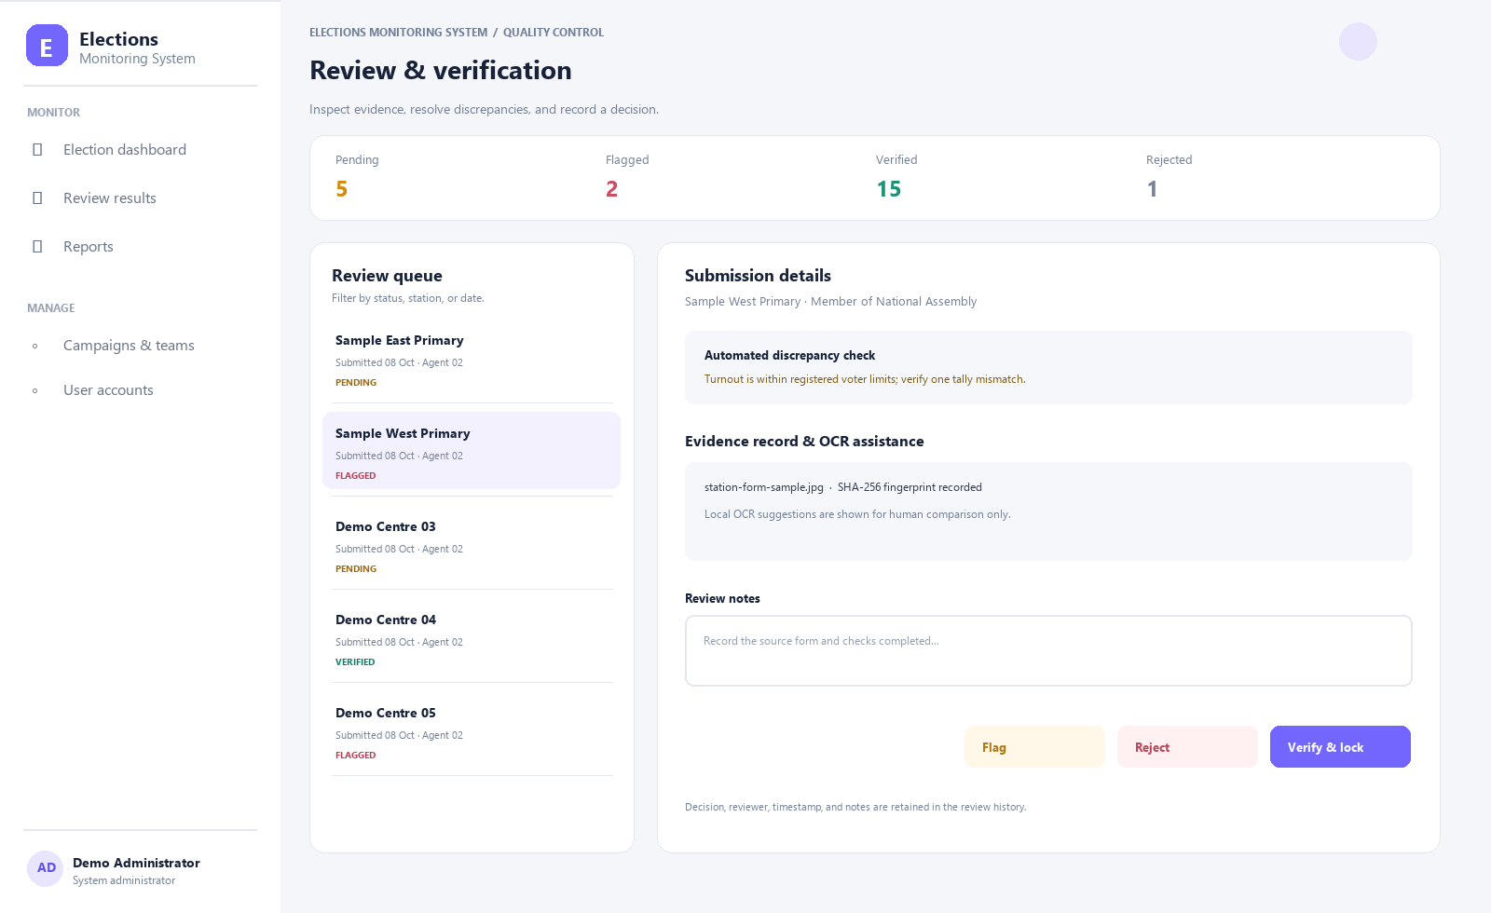
Illustrative interface preview based on the current system workflow
A practical election operations workspace
A role-based web system for election preparation, field result capture, review, and verified reporting. This document describes the current application and a proposed path to operational deployment.

Suggested delivery: 12 to 15 minutes, followed by discussion. Use the talk track as a guide, then demonstrate the live application with a prepared test account and sample data. The interface previews in this guide use fictional sample names and figures.

Meeting objectives
By the end of the discussion, stakeholders should understand how the system links station preparation, agent reporting, human review, and verified reporting. The meeting should also identify what remains to be configured and tested before a pilot.

Suggested run of show
2 minutes. Current coordination needs and intended outcome.
7 minutes. Walkthrough of setup, agent submission, review, and reports.
3 minutes. Access boundaries, KYC privacy, and readiness conditions.
3 minutes. Agree pilot scope, owners, and next actions.
Before the meeting
Use a test account and fictional records. Confirm the demo environment, report exports, mail setup, and local OCR status. Do not display real identity documents or live election data on a projector.

Suggested opening
“Today we will walk through how election setup, assigned field reporting, human review, and verified reports fit into one workflow. We will also identify the operational and privacy decisions that must be agreed before a pilot.”

Demo preparation checklist
- Sign in with a prepared test account for each role you plan to show.
- Use fictional submissions and sample evidence only.
- Confirm report downloads and browser display on the presentation device.
- Keep a printed or offline copy of the agenda and pilot questions.

PRESENTATION SECTION 01

The operational need
Key message
Election operations span many polling stations, field teams, and reviewers. Stakeholders need a shared view of what has been submitted, what requires attention, and which results have completed review.

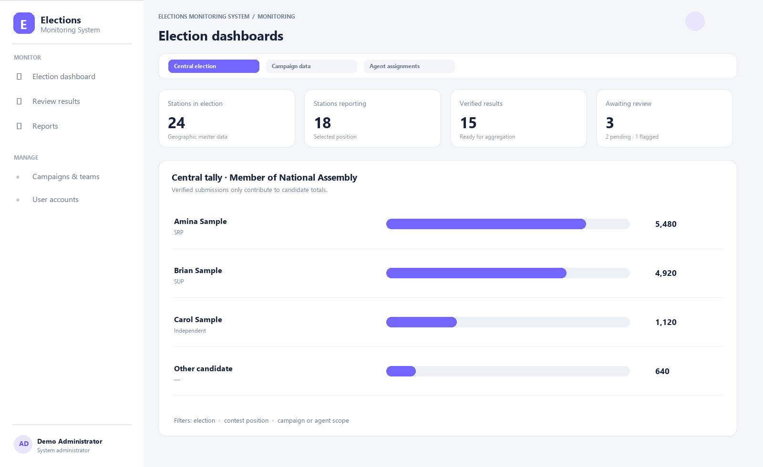
Illustrative interface preview · fictional sample data

Presenter notes
Open by asking how the team currently receives, compares, and summarizes station results. Frame the system as an operational workflow and evidence record, not as an election authority or a substitute for official results processes.

Demo cue
Opening and context

PRESENTATION SECTION 02

One workflow from setup to report
Key message
The platform connects election geography, contests, candidates, campaigns, agent assignments, field submissions, review, and verified reporting.

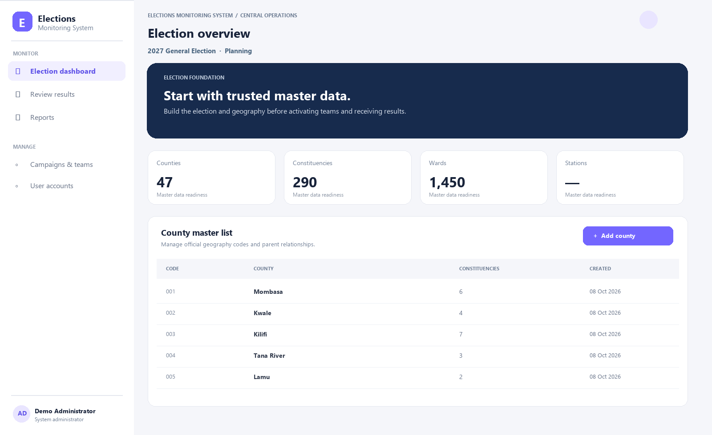
Illustrative interface preview · fictional sample data

Presenter notes
Walk through the sequence: establish trusted reference data; give users scoped access; assign agents to stations; capture figures and source forms; review and lock records; publish authorized summaries.

Demo cue
Show election setup

PRESENTATION SECTION 03

Field teams submit from assigned stations
Key message
Agents enter station-level figures and attach the source form. Active assignments constrain which stations they can submit for. The responsive web experience works in a mobile browser.

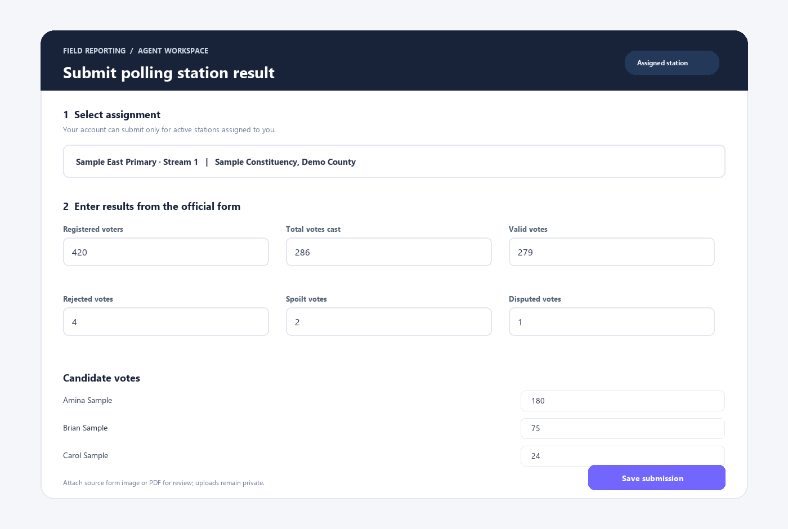
Illustrative interface preview · fictional sample data

Presenter notes
Demonstrate the agent view with a test account. Enter sample totals and show the validation cues. Explain that Flutter and offline capture are future work and not part of the current release.

Demo cue
Show the form on a phone-sized browser

PRESENTATION SECTION 04

Review keeps submitted and verified data distinct
Key message
Reviewers inspect evidence, run discrepancy checks, record notes, and decide whether to verify, flag, or reject. Verified records are locked for aggregation.

Illustrative interface preview · fictional sample data

Presenter notes
Open one sample submission. Point to its evidence, arithmetic checks, status, review notes, and history. Explain that local OCR suggests text for human comparison and never changes vote counts on its own.

Demo cue
Show queue and detail

PRESENTATION SECTION 05

Reports answer geographic questions
Key message
Authorized reports can be filtered by election, contest, candidate, and geography. Current exports include CSV, Excel, and PDF and aggregate verified records.

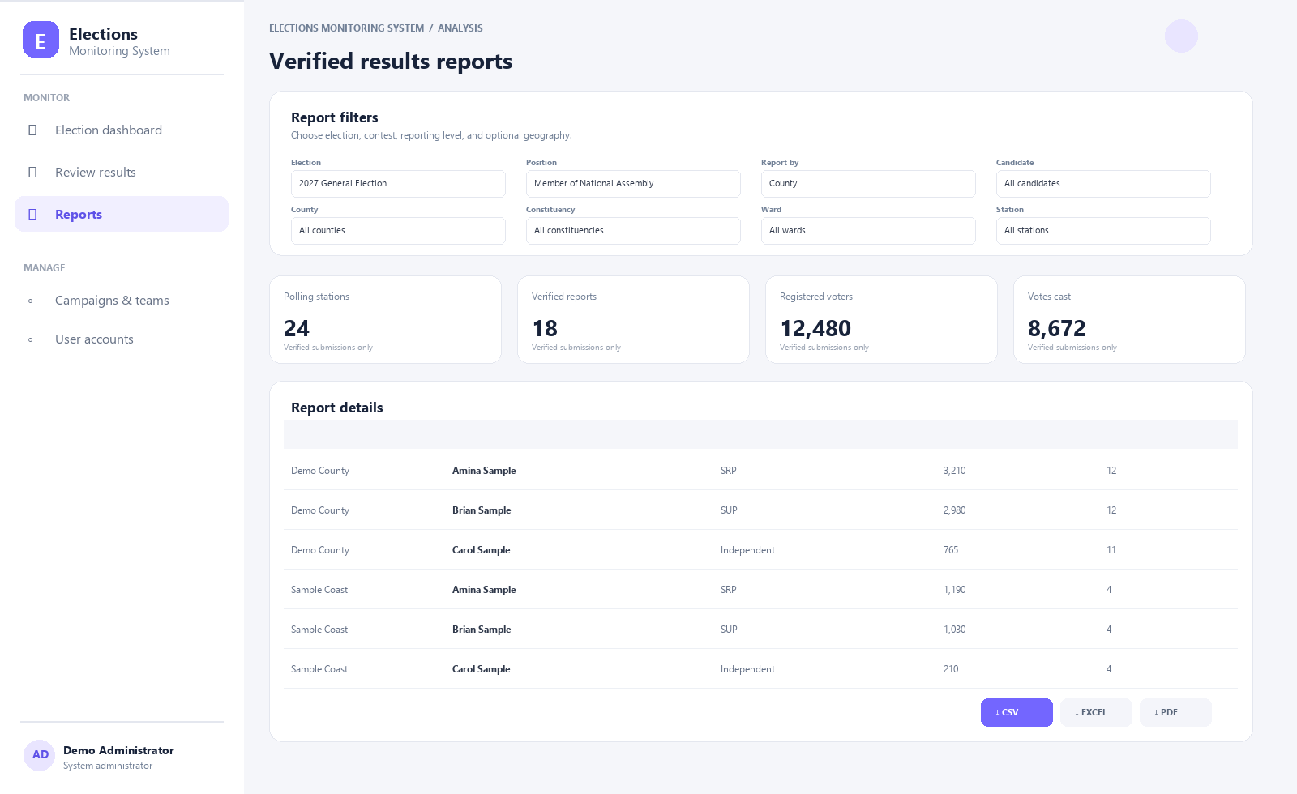
Illustrative interface preview · fictional sample data

Presenter notes
Change the report level from national to county or polling station. Show the metrics and result table, then identify who may access and share each export.

Demo cue
Show filters and exports

PRESENTATION SECTION 06

Access follows assigned responsibility
Key message
System and campaign roles determine what a user can see or do. Agents submit only against active station assignments; system administrators manage configuration; authorized reviewers record decisions.

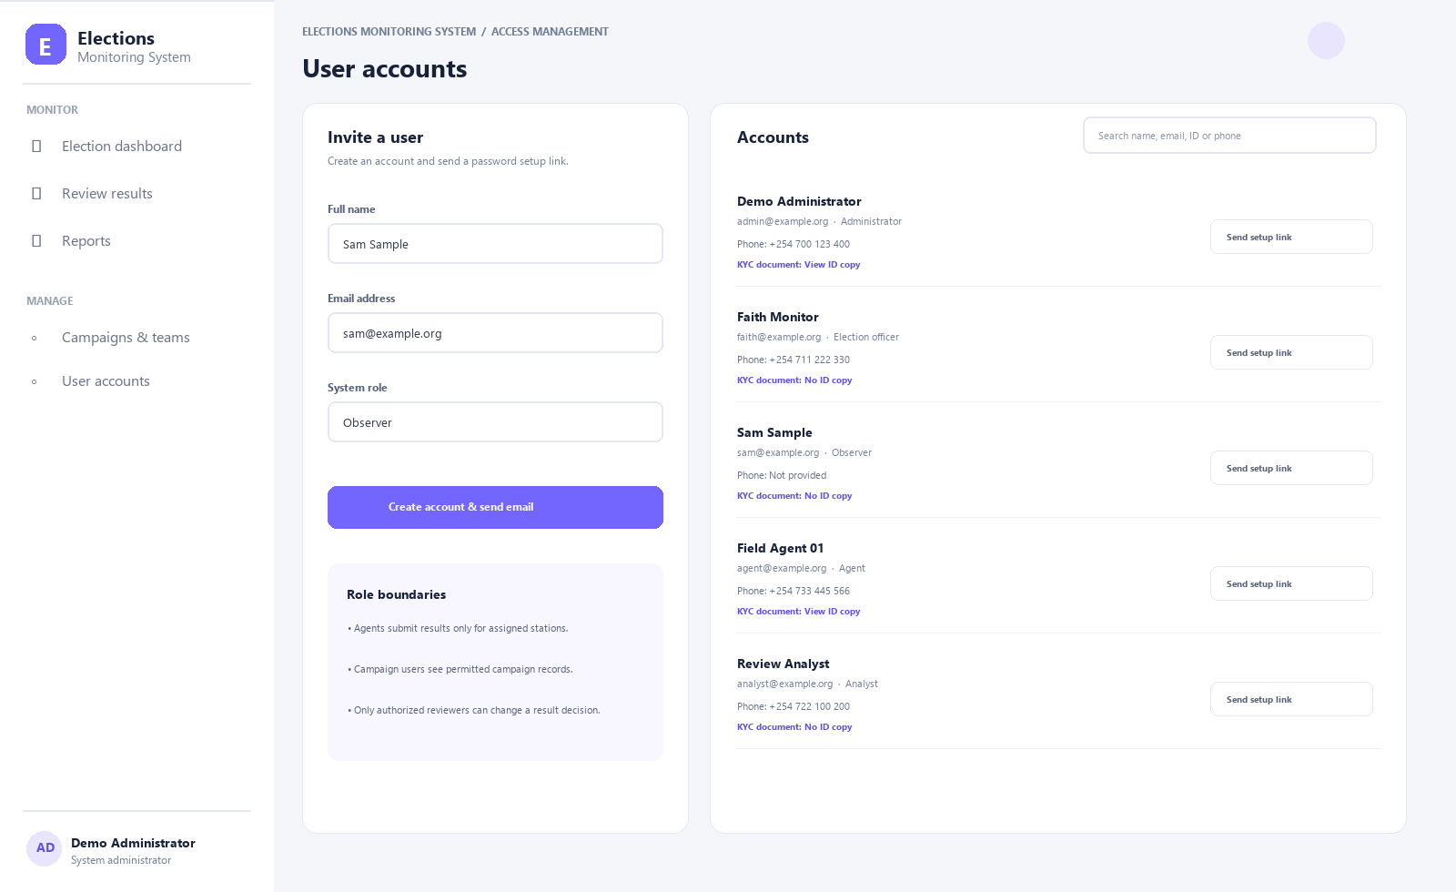
Illustrative interface preview · fictional sample data

Presenter notes
Show account provisioning and the navigation available to the selected role. Describe how invitation links and password setup avoid shared default credentials. Confirm the proposed access matrix with stakeholders.

Demo cue
Show accounts and role separation

PRESENTATION SECTION 07

Pilot before election operations
Key message
A controlled pilot validates official data, role boundaries, field usability, review rules, reports, infrastructure, backups, and support.

Illustrative interface preview · fictional sample data

Presenter notes
Ask stakeholders to nominate a pilot contest and area, data owners, field representatives, reviewers, and technical leads. Agree how success and go/no-go decisions will be measured.

Demo cue
Close with decisions and actions

Discussion and decision record
Use the questions below to turn the demonstration into a practical pilot plan. Record the stakeholder answer, named owner, and target date during the meeting.
Pilot election, contest, and geography Owner: ____________________ Date: __________
Official source for election and polling-station data Owner: ____________________ Date: __________
Role owners and agent assignment approach Owner: ____________________ Date: __________
Evidence and discrepancy review rules Owner: ____________________ Date: __________
Required reports and authorized recipients Owner: ____________________ Date: __________
Hosting, email, local OCR, backup, and support owners Owner: ____________________ Date: __________
KYC document privacy and retention policy Owner: ____________________ Date: __________
Pilot acceptance measures and go/no-go date Owner: ____________________ Date: __________

Questions stakeholders may ask

Does the system declare official results?
No. It organizes submitted information, review decisions, and verified-record reports. Official processes remain authoritative.

Does OCR decide vote totals?
No. Local OCR can suggest text for a human to compare with the source form; it does not modify or approve totals.

Can agents change any station result?
No. Submission is limited to active assignments; review and locking are separately permissioned.

Can users submit while offline?
Offline capture is not in the current web release. Connectivity requirements should be tested in the pilot.

Is this ready for production today?
The application provides the described workflows. Production use depends on completing hosting, security, privacy, data, recovery, and acceptance readiness checks.
Close
Agree the pilot scope, owners, and readiness checklist. Do not introduce live identity documents or election data until access, privacy, and operational controls are approved.

